**Report about conducted load test**

**Date:** 04/07/2022

**Author:** Vladyslav Kliucharov

**Application:** BlogEngine.NET version 3.2

**Environment:** Test Environment VirtualBox (Version 6.1.34 r150636 (Qt5.6.2))

**Test Environment configuration(RAM, CPU etc.):**

|  |  |
| --- | --- |
| **Processor** | 11th Gen Intel(R) Core(TM) i7-1185G7 @ 3.00GHz 3.00 GHz (4 core) |
| **RAM** | 4 GB |
| **Hard Disk** | 60 GB |
| **Operating System** | Windows 10 Enterprise (21H2) |

1. **Why such testing was conducted:**

The report is included two methods of testing:

1. Smoke testing - was conducted to verification that the crucial functions of a program can be run and executed in the main workflow

2. Scalability Testing- was conducted to define and ensure that the system can handle the scaling of CPU and RAM performance goals

1. **Test script description:**

The features to be tested have been logically grouped to be covered by 3 threads of users "Admin script", "Editor script" and "Anonymous script". These scenarios were combined in one script followed by load requirement analysis for the modules. The below table captures the features covered by each script. The implement probabilities usage was divided by percentages for all threads (shown below tables):

|  |  |
| --- | --- |
| **Admin script** | **Editor script** |
|  |  |

|  |  |  |
| --- | --- | --- |
|  | **Anonymous script** |  |
|  |  |  |

Scenario to implement probabilities usage:

|  |  |
| --- | --- |
| 1. Home Page: 15%  2. Open Random Date: 10%  3. Open Predefined Date: 30%  4. Search by Name: 30%  5. Open Large Calendar: 10%  6. Open Contacts: 5% | 1. Open Random page (yes/no): 50% / 50%  2. Open post (yes/no): 80% / 20%  3. Random or First (yes/no): 65% / 35%  4. Comment (yes/no): 20% / 80% |

1. **Tests:**  
   **Test run preconditions:**

* CSV file with Random dates
* Warmup script was running before each test run
* Before each new test script run, the webserver was reloaded, the test executed in NON-GUI mode
* Using results of the testing from Task 7 define regular load
* Define general Key Performance Indicators (KPI), and get their basic value using the results from Task 7
* There were used 6 Scale Models**:**

|  |  |  |
| --- | --- | --- |
|  | **CPU quantity** | **RAM quantity** |
| **Scale Model 1 (CPU)** | 1 | 4GB |
| **Scale Model 2 (CPU)** | 2 | 4GB |
| **Scale Model 3 (CPU)** | 3 | 4GB |

|  |  |  |
| --- | --- | --- |
|  | **CPU quantity** | **RAM quantity** |
| **Scale Model 1 (RAM)** | 1 | 2GB |
| **Scale Model 2 (RAM)** | 1 | 4GB |
| **Scale Model 3 (RAM)** | 1 | 8GB |

|  |  |  |
| --- | --- | --- |
|  | **CPU quantity** | **RAM quantity** |
| **Load Model (from task 7)** | 2 | 8GB |

Scenarios model (was used similar for all scale)

|  |  |  |  |  |  |
| --- | --- | --- | --- | --- | --- |
| **Thread Group** | **Maximum number of simultaneous users** | **Ramp-Up period** | **Test duration** | **Probabilities usage** | **Number of posts quantity** |
| Thread Group (Admin users) | 2 | 200 | 800 (sec.) | Pre-Defined | 1000 |
| Thread Group (Editor users) | 10 | 100 | 800 (sec.) | Pre-Defined | 1000 |
| Thread Group (Anonymous users) | 70 | 700 | 800 (sec.) | Pre-Defined | 1000 |

1. **Short summary on conducted tests:**

For the scaling of CPU, the test used 3 “Scale models” with 1,2 and 3 of CPUs

For the scaling of RAM, the test used 3 “Scale models” with 2GB, 4GB and 8GB of RAM

1. **Detailed test results:**

‘Task8’ scripts were running 6 times, according to the scalability CPU testing results, the results and behavior were different:

|  |  |  |  |  |  |  |
| --- | --- | --- | --- | --- | --- | --- |
| **Scale Model 1 (CPU) (Best config)** | Run # | Total Requests | Total Errors Num | Max Throughput | Response Times (90th Percentile (Mean) | Response time average |
|  | 1 | 4257 | 188 | 73 | 11.8 sec | 4.82 sec |
|  | 2 | 4073 | 206 | 56 | 17.1 sec | 5.60 sec |
| **Scale Model 2 (CPU)** | Run # | Total Requests | Total Errors Num | Max Throughput | Response Times (90th Percentile (Mean) | Response time average |
|  | 1 | 4162 | 265 | 54 | 17.6 sec | 5.86 sec |
|  | 2 | 3851 | 239 | 61 | 18.7 sec | 7.07 sec |
| **Scale Model 3 (CPU)** | Run # | Total Requests | Total Errors Num | Max Throughput | Response Times (90th Percentile (Mean) | Response time average |
|  | 1 | 4110 | 288 | 49 | 16.9 sec | 5.38 sec |
|  | 2 | 4082 | 268 | 51 | 21.9 sec | 6.32 sec |

|  |  |  |  |  |  |  |
| --- | --- | --- | --- | --- | --- | --- |
| **Scale Model 1.1 (RAM)** | Run # | Total Requests | Total Errors Num | Max Throughput | Response Times (90th Percentile (Mean) | Response time average |
|  | 1 | 918 | 16 | 26 | 31.6 sec | 1.94 min |
|  | 2 | 1073 | 38 | 20 | 26.8 sec | 1.49 min |
| **Scale Model 1.2 (RAM) (Best config)** | Run # | Total Requests | Total Errors Num | Max Throughput | Response Times (90th Percentile (Mean) | Response time average |
|  | 1 | 9143 | 61 | 96 | 2.33 sec | 880 ms |
|  | 2 | 6870 | 52 | 80 | 5.76 sec | 1.66 sec |
| **Scale Model 1.3 (RAM)** | Run # | Total Requests | Total Errors Num | Max Throughput | Response Times (90th Percentile (Mean) | Response time average |
|  | 1 | 6755 | 97 | 107 | 6.39 sec | 1.60 sec |
|  | 2 | 6368 | 102 | 103 | 7.57 sec | 1.83 sec |

**Test Run #1 (Scale Model 1 (CPU))**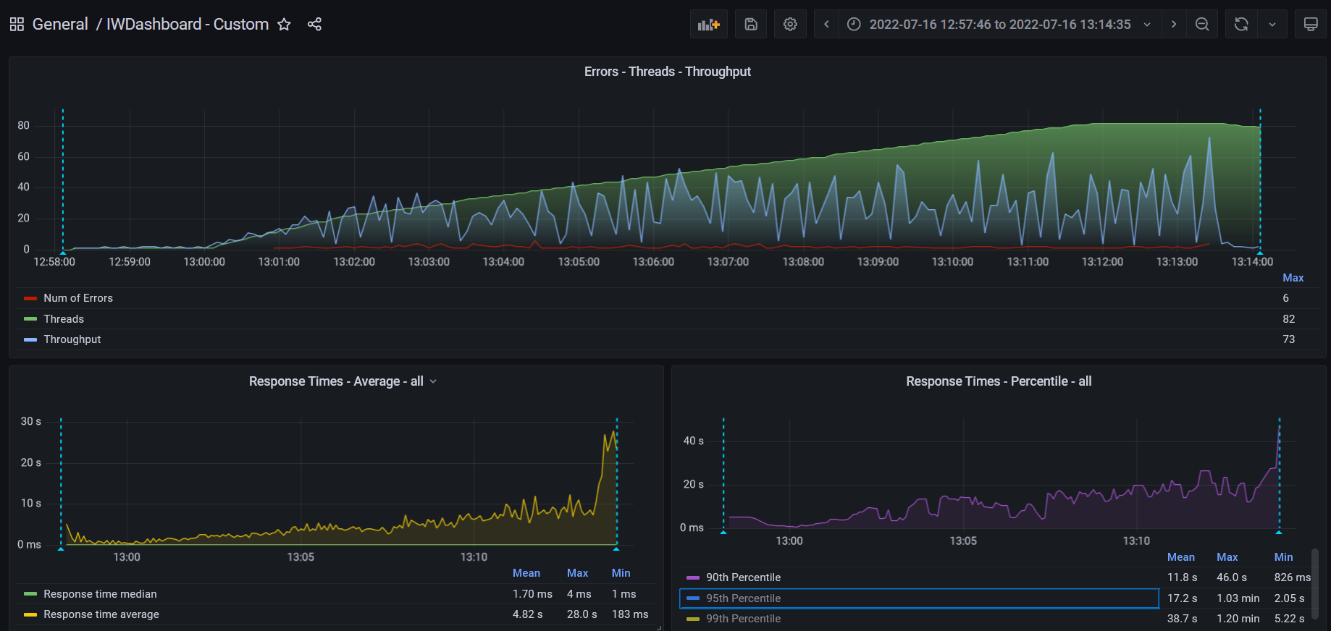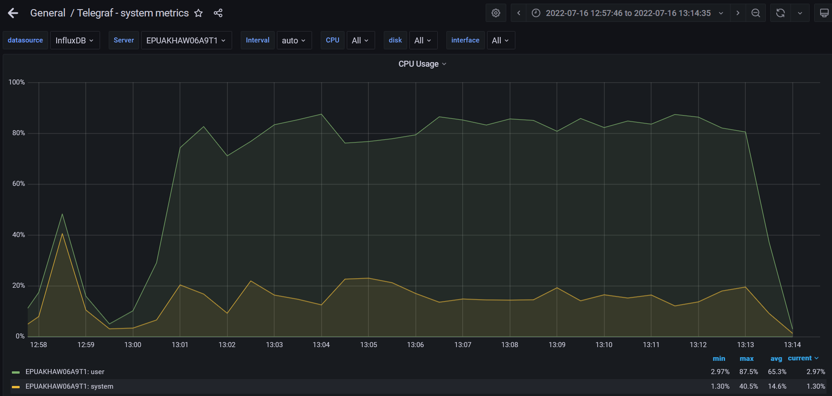

**Test Run #2 (Scale Model 1 (CPU))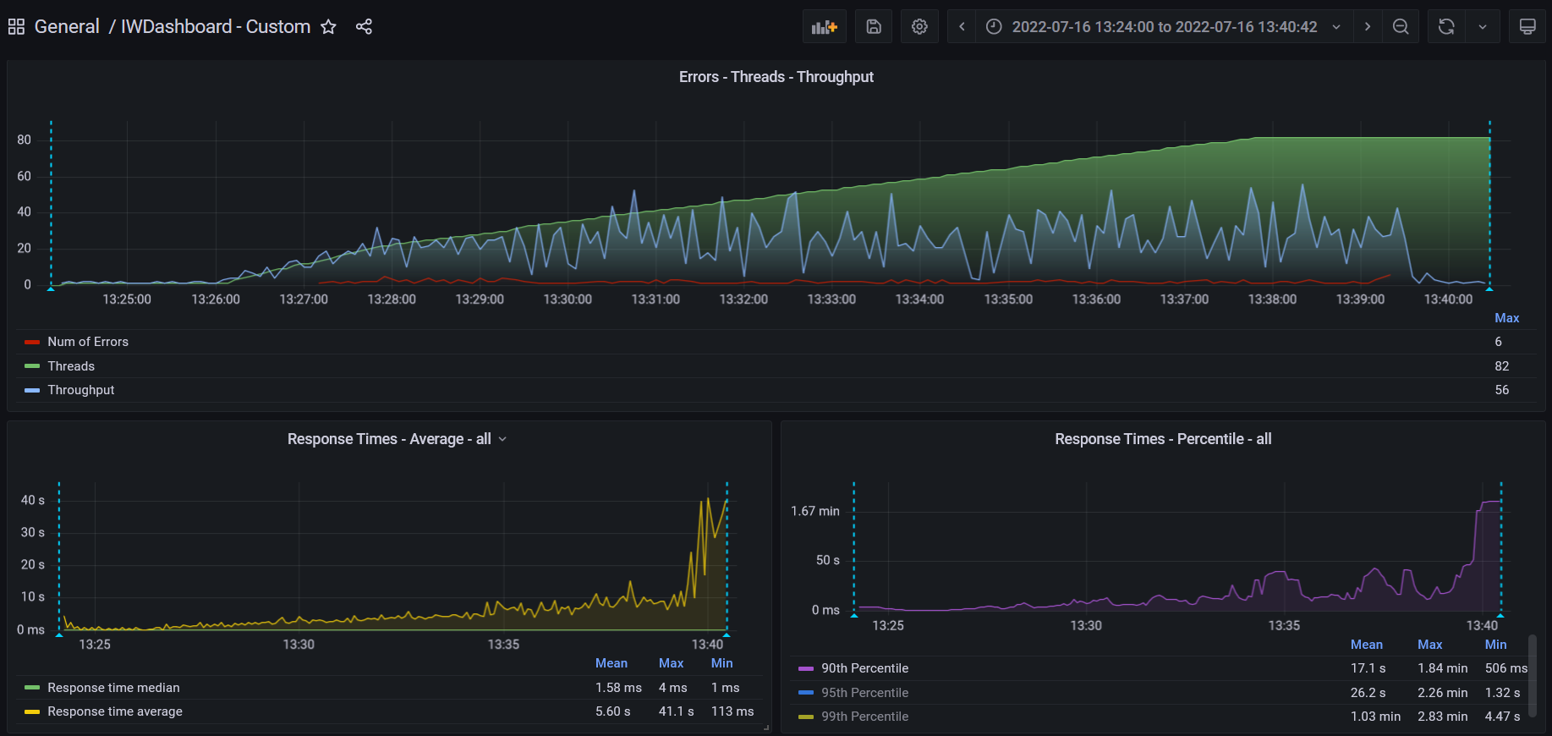**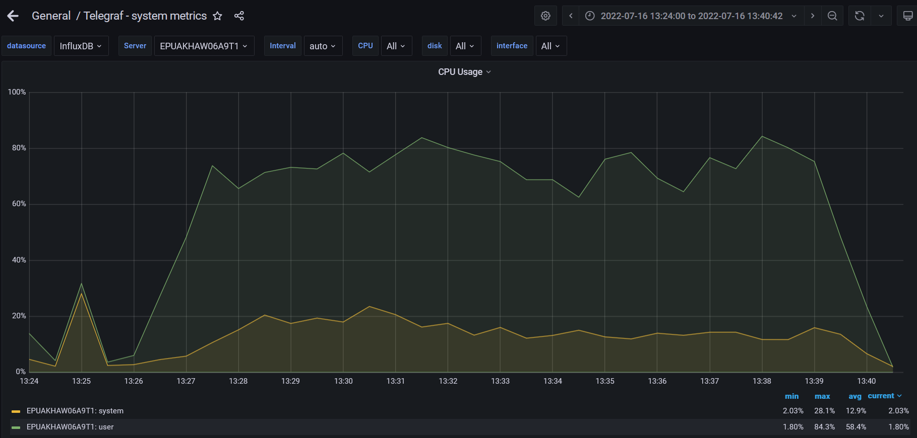

**Test Run #1 (Scale Model 2 (CPU))**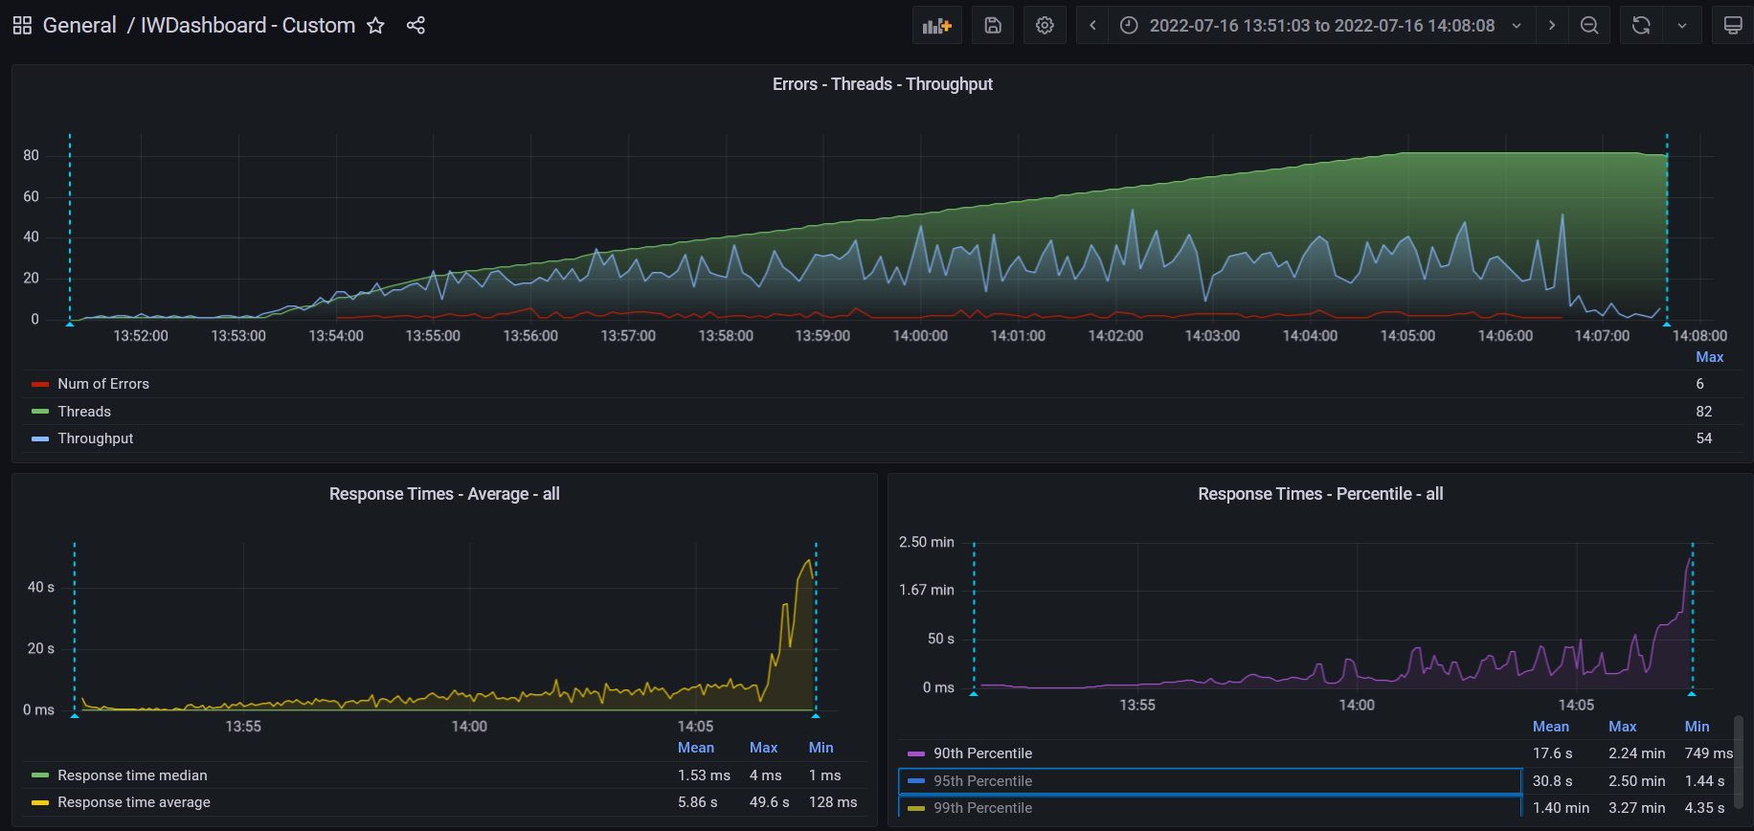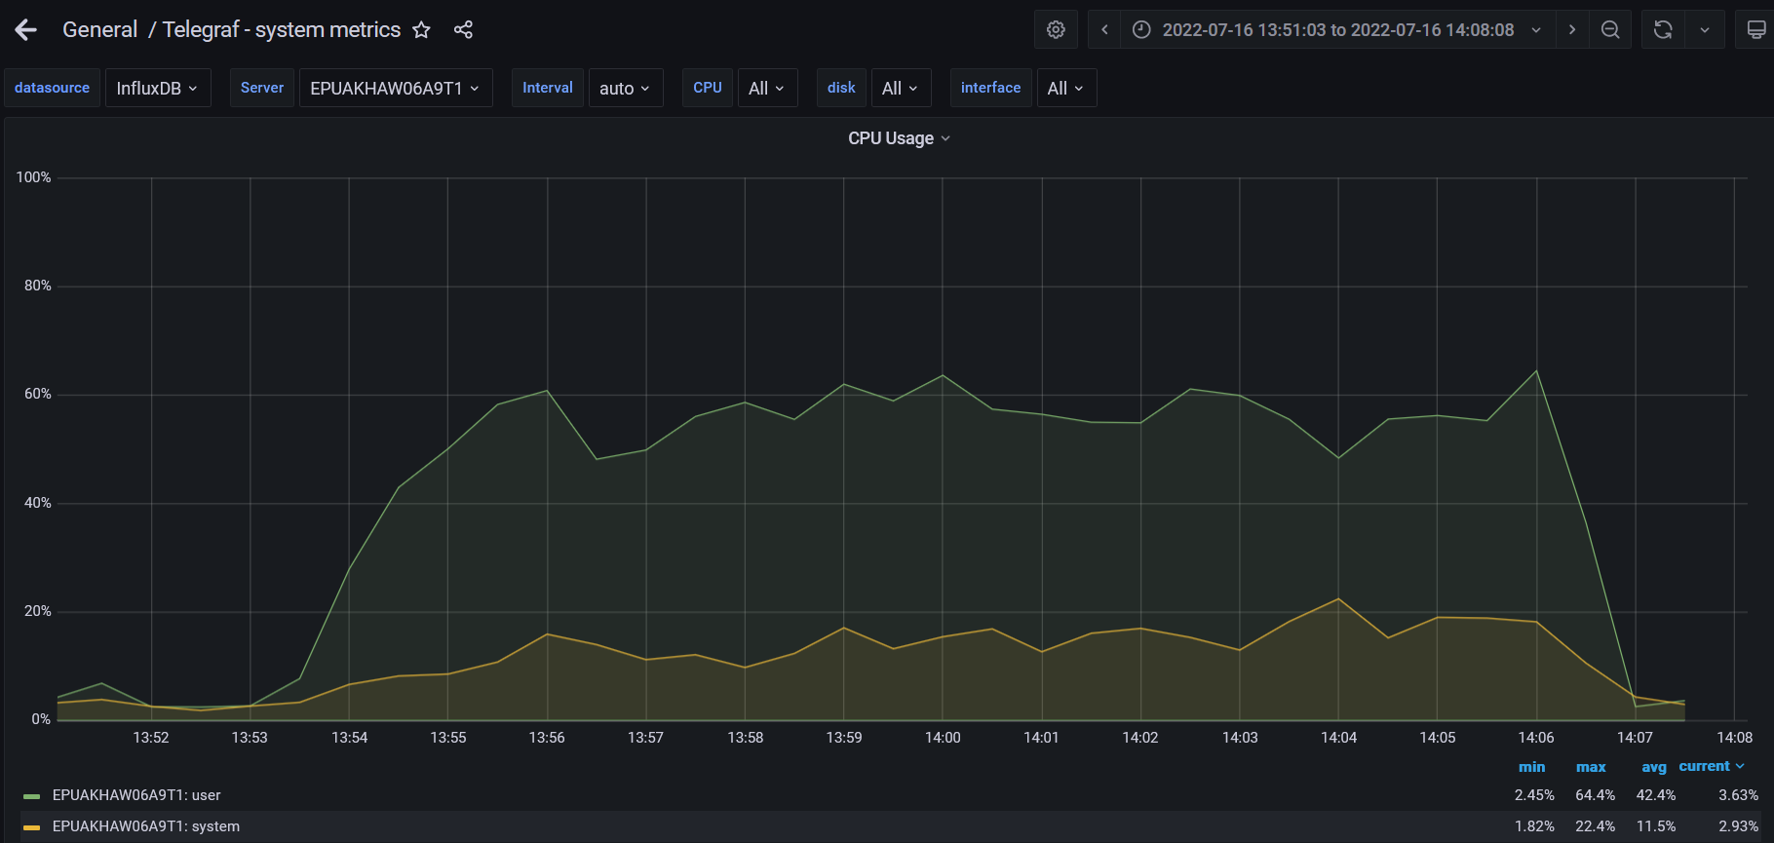

**Test Run #2 (Scale Model 2 (CPU))**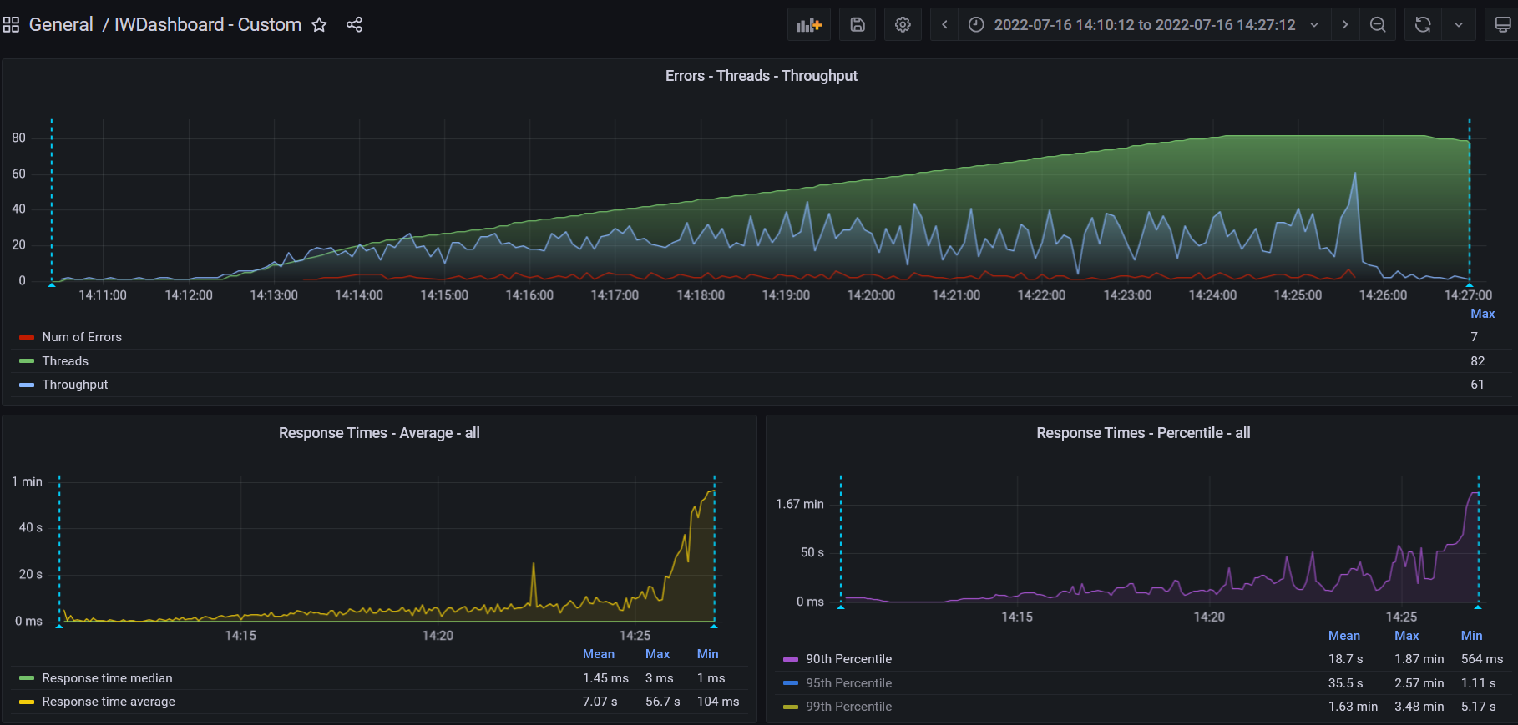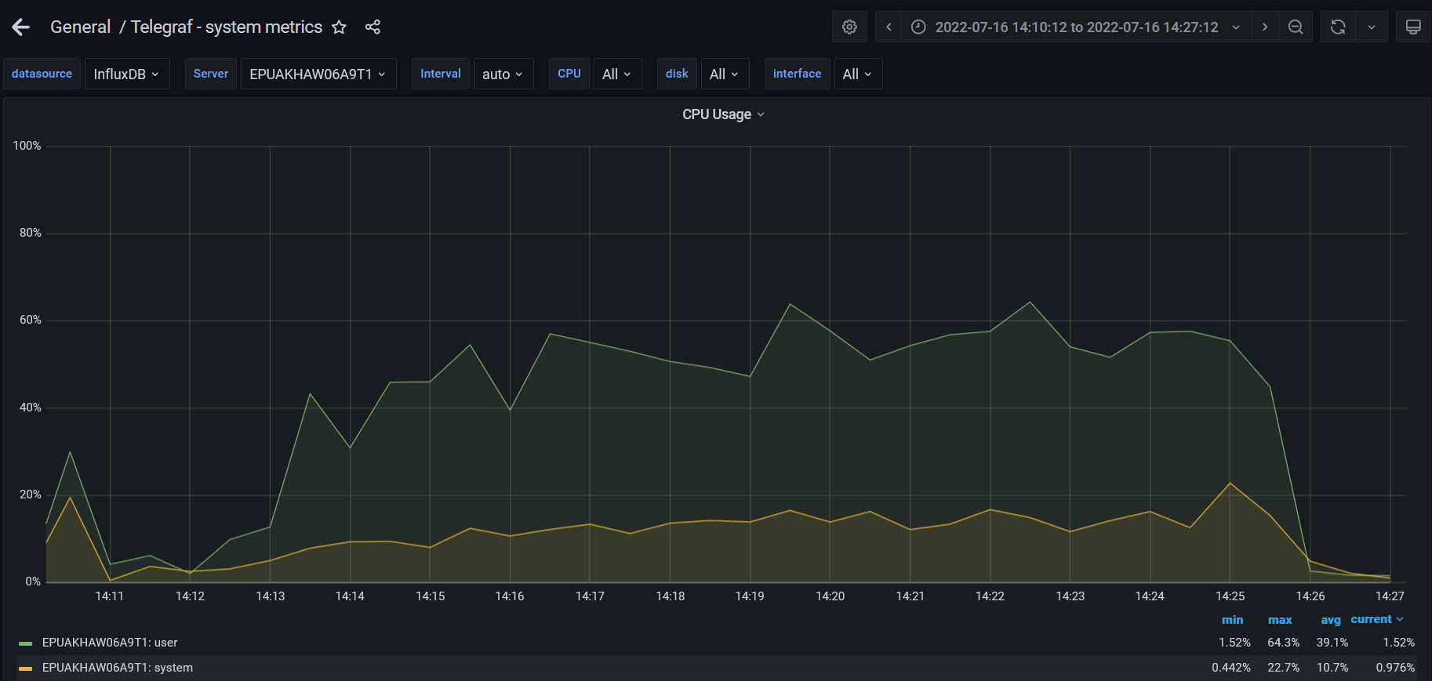

**Test Run #1 (Scale Model 3 (CPU))**

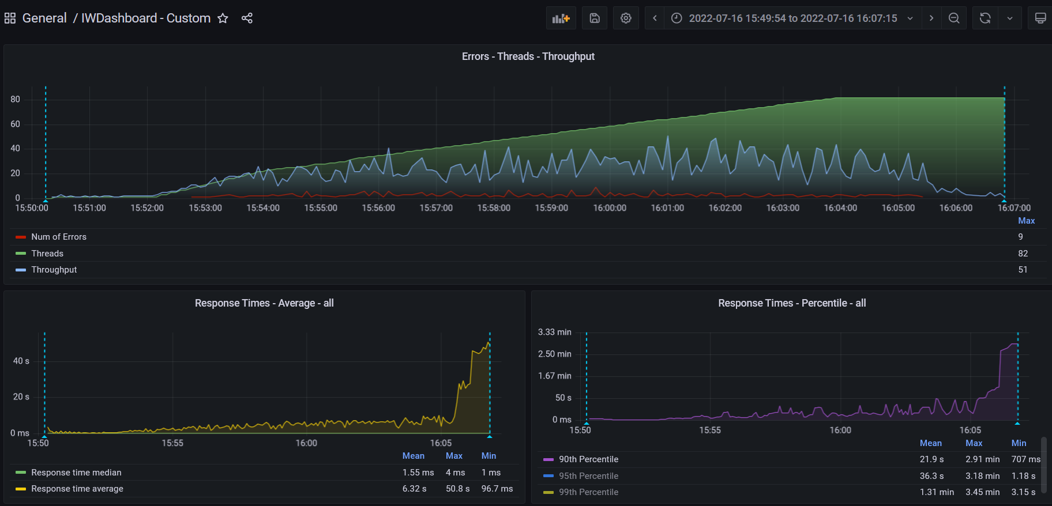

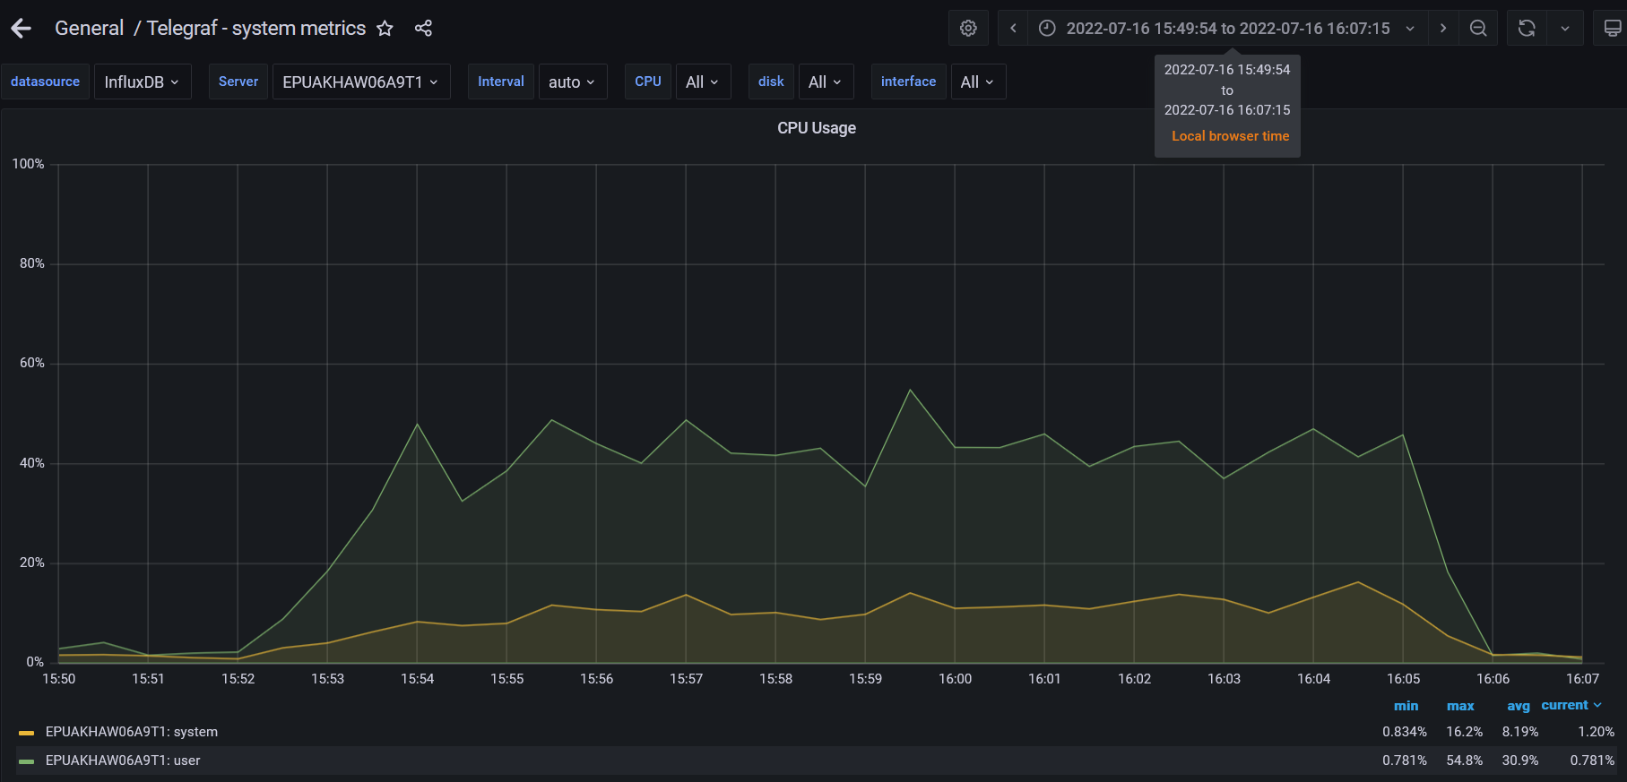

**Test Run #2 (Scale Model 3 (CPU))**

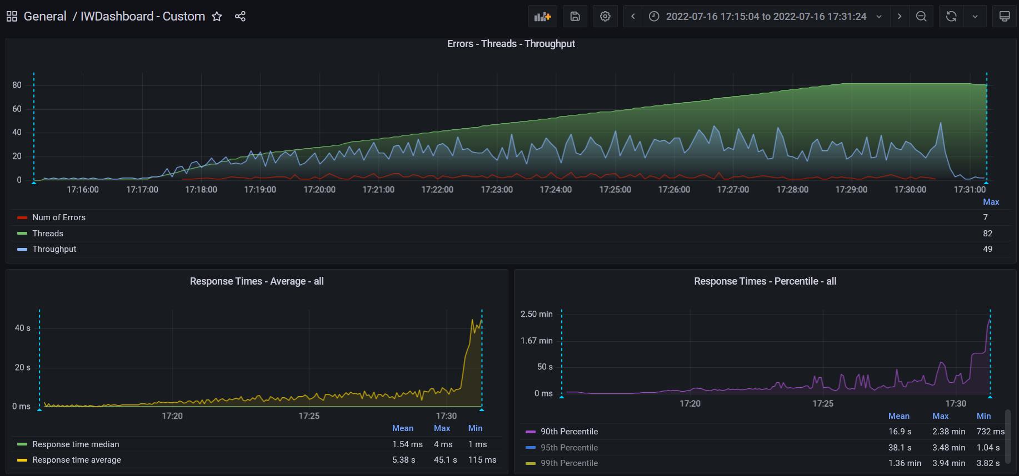

**Test Run #1 (Scale Model 1 (RAM))**

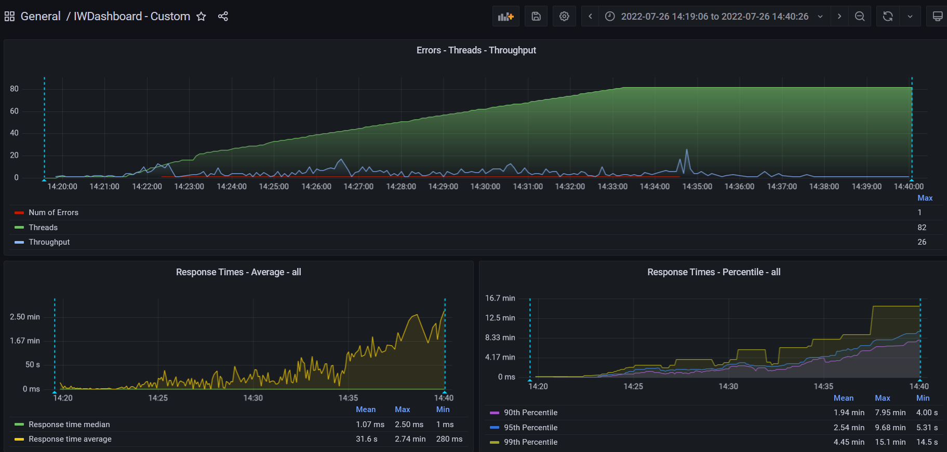

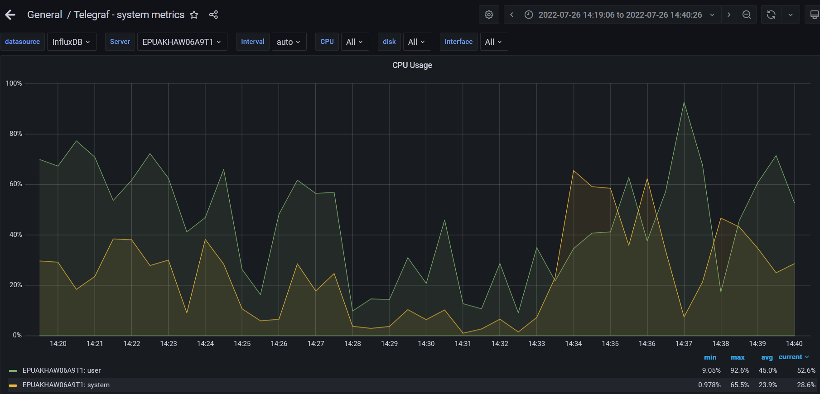

**Test Run #2 (Scale Model 1 (RAM))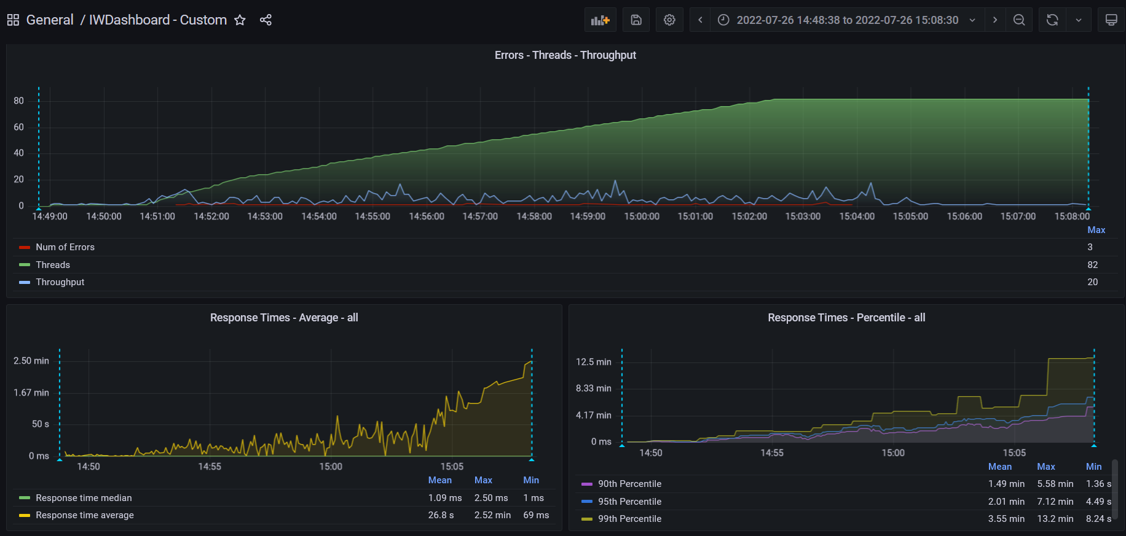**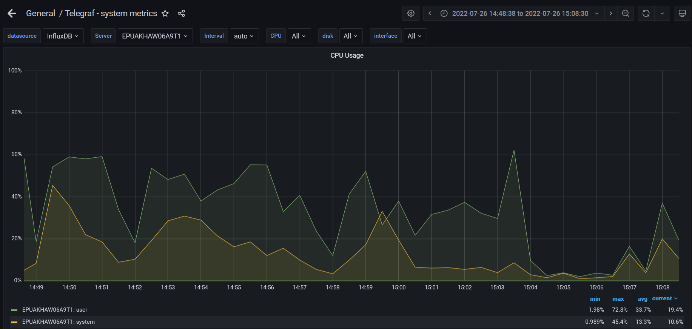

**Test Run #1 (Scale Model 2 (RAM))**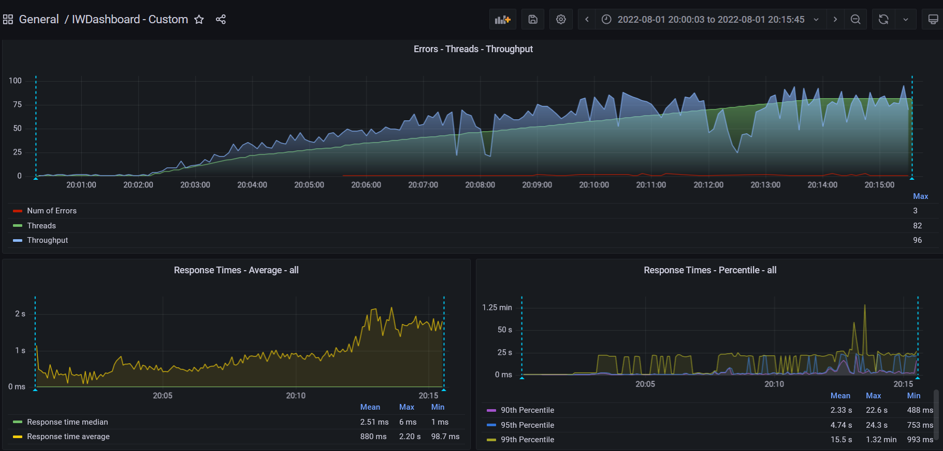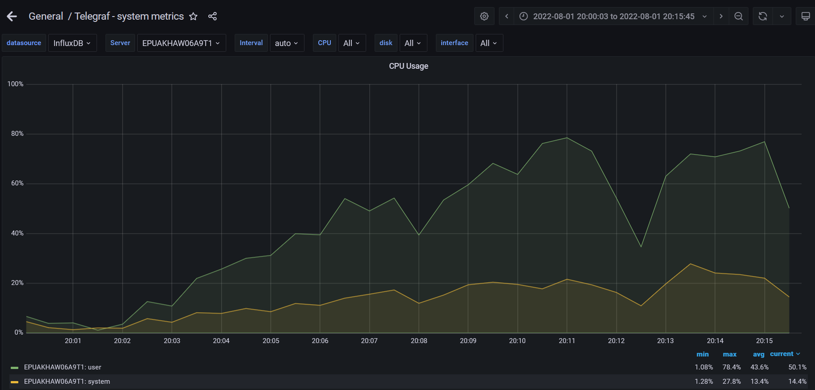

**Test Run #2 (Scale Model 2 (RAM))**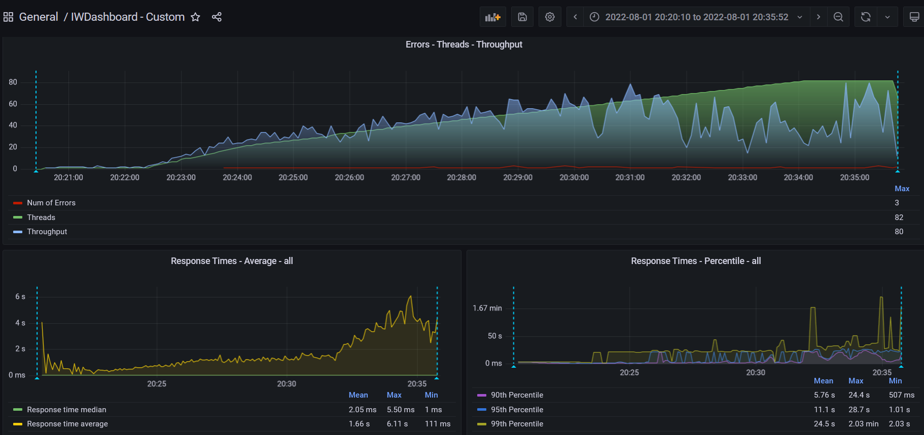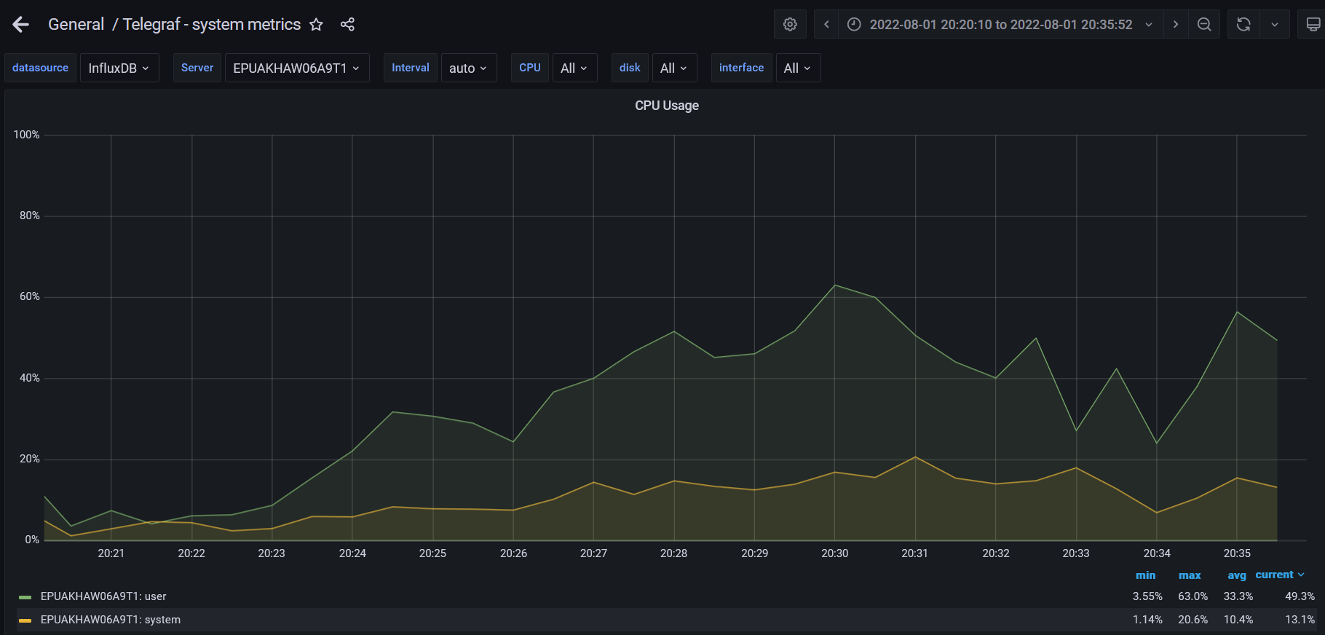

**Test Run #1 (Scale Model 3 (RAM))**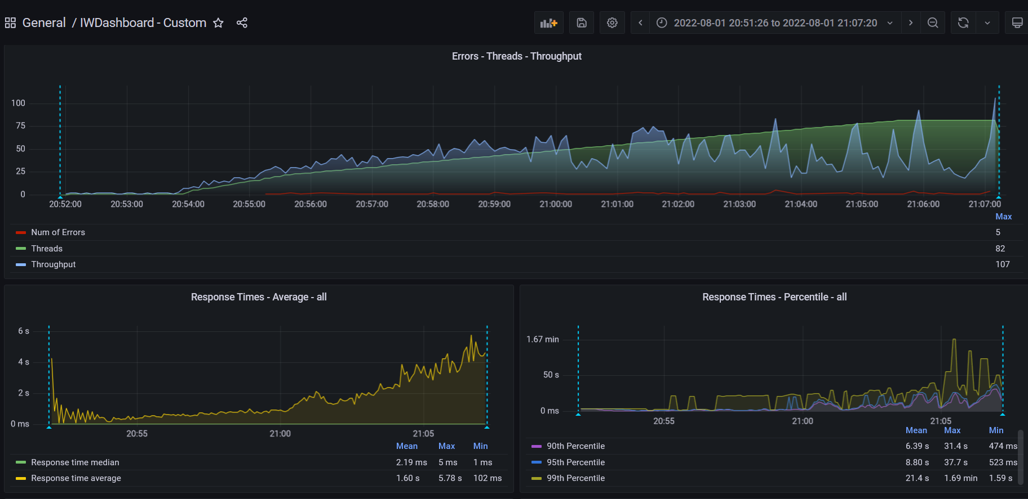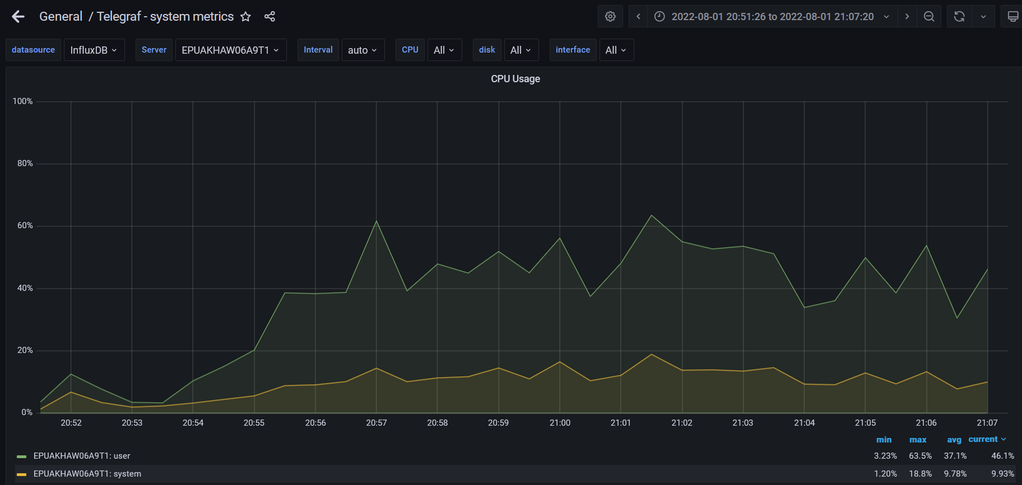

**Test Run #2 (Scale Model 3 (RAM))**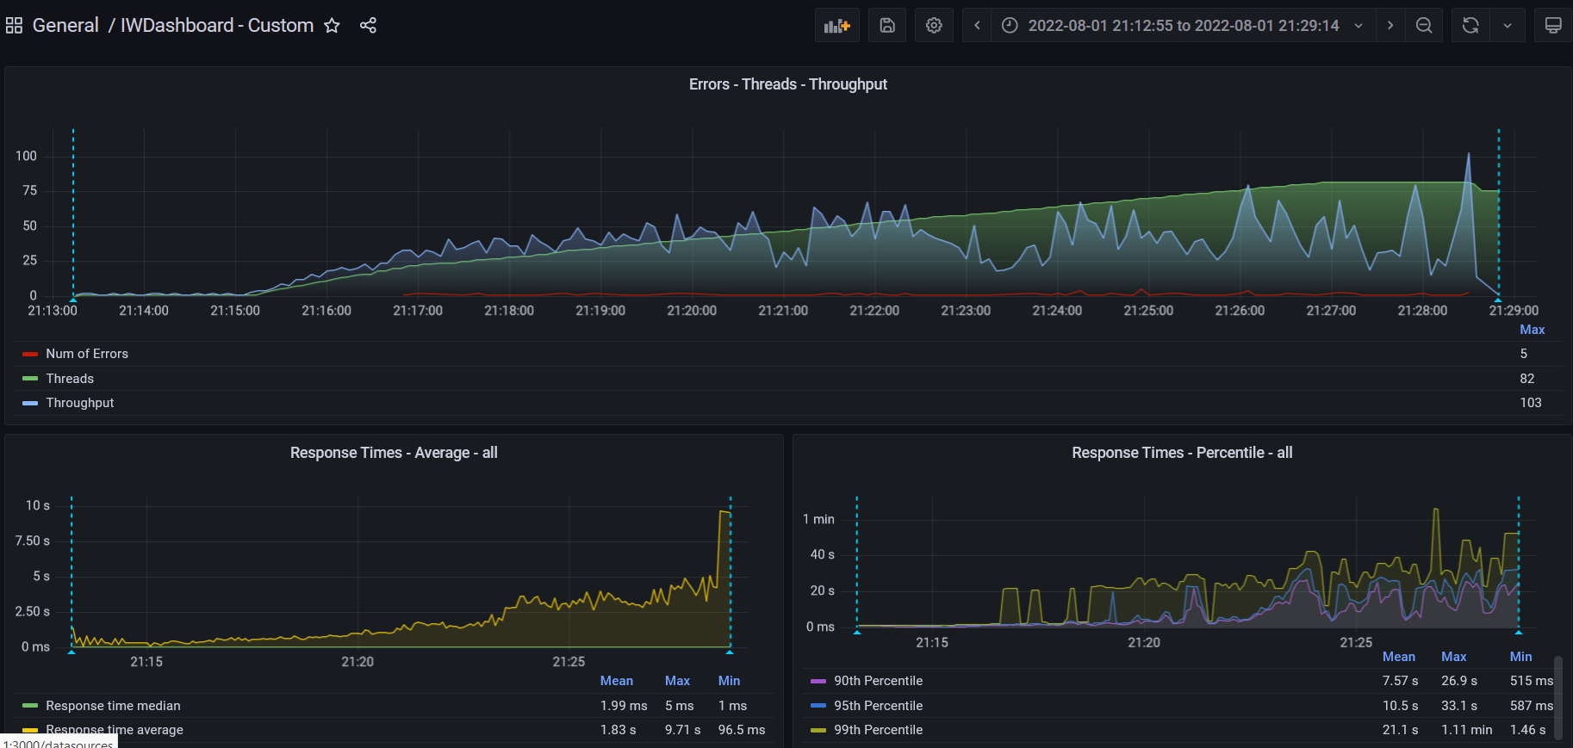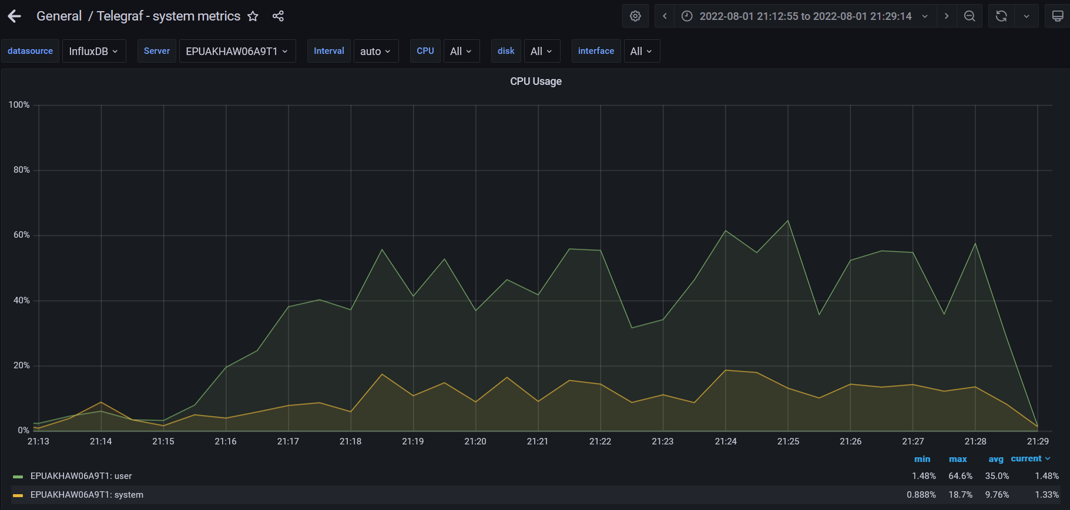

1. **Conclusion:**

The server worked stable according to the received test results by 6 runs for CPU for 1,2,3 CPU. The best result was defined for using the app on 1 CPU. For testing RAM by 2GB,4GB, and 8GB next 6 runs, the best result was defined as 4GB. Main parameters for marks are Total Errors, Num Max Throughput, Response time average. The appropriate params for server work are 1 CPU and 4GB of RAM

**General Key Performance Indicators (KPI) from Task 8**

|  |  |  |  |  |  |
| --- | --- | --- | --- | --- | --- |
| Run # | Total Requests | Total Errors Num | Max Throughput | Response Times (90th Percentile (Mean) | Response time average |
| 1 | 9143 | 61 | 96 | 2.33 sec | 880 ms |
| 2 | 6870 | 52 | 80 | 5.76 sec | 1.66 sec |

**General Key Performance Indicators (KPI) from Task 7**

|  |  |  |  |  |  |
| --- | --- | --- | --- | --- | --- |
| Run # | Total Requests | Total Errors Num | Max Throughput | Response Times (90th Percentile (Mean) | Response time average |
| 1 | 5890 | 495 | 58 | 13.8 sec | 3.73 sec |
| 2 | 5960 | 477 | 65 | 12.5 sec | 4.33 sec |